**DAY 18**

|  |
| --- |
| * **PART 7: Single-Double-Triple passage Skimming Practice** * **LISTENING PRACTICE** |

**Part 7: Skimming practice**

Exercise 1 (Part 7) 158-175 Single passage

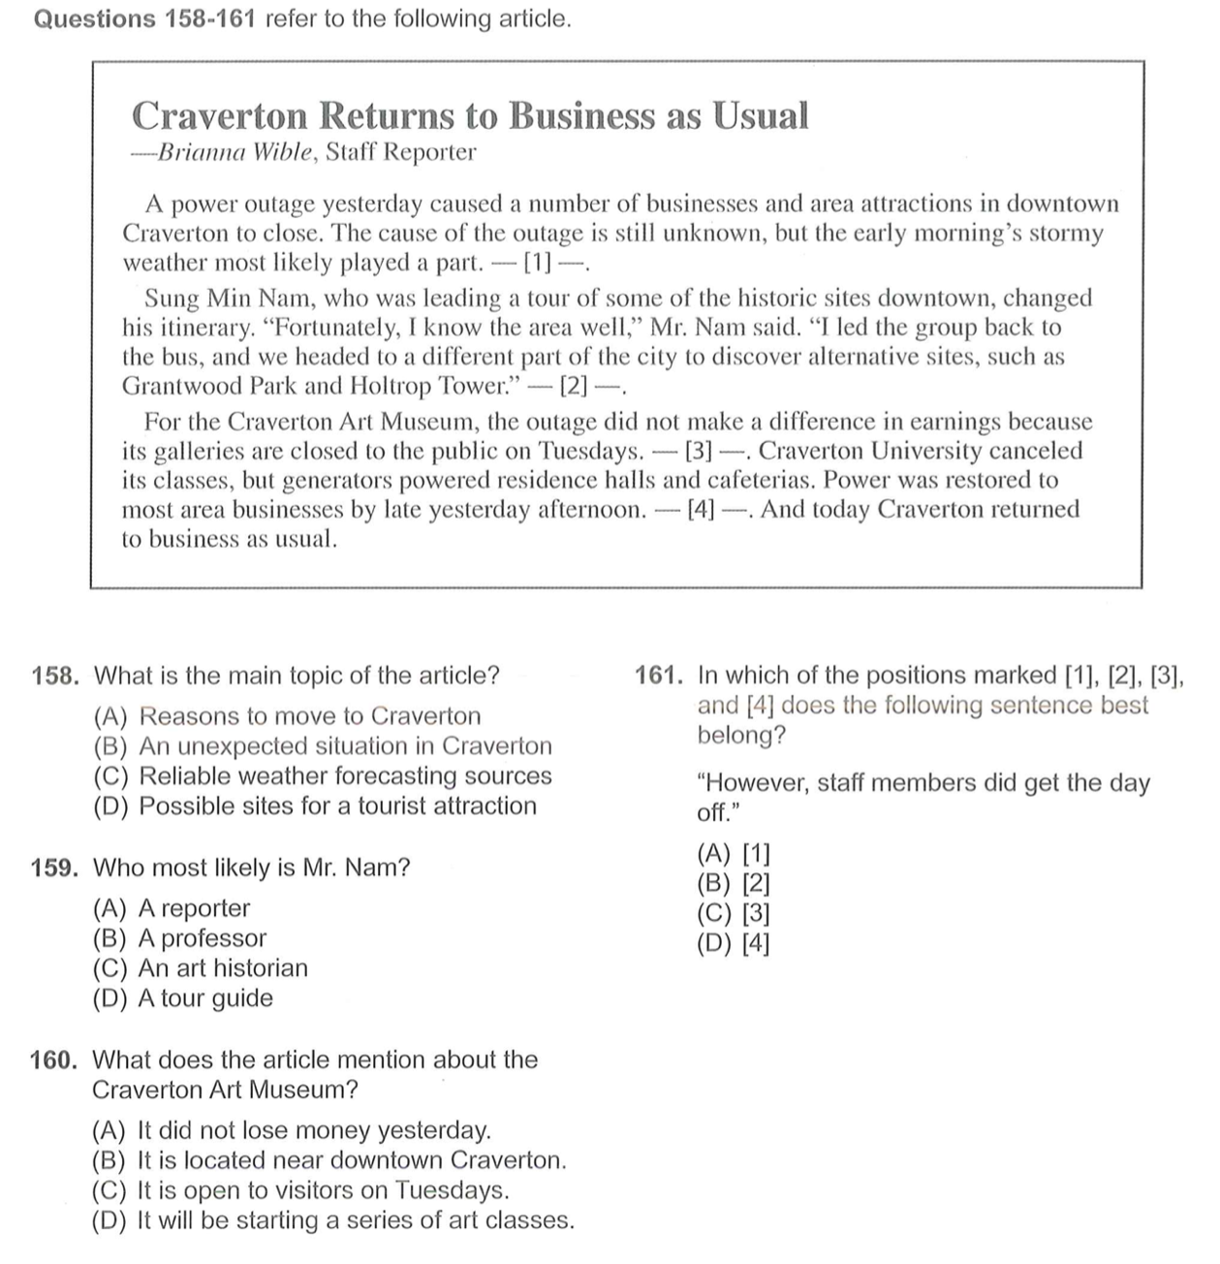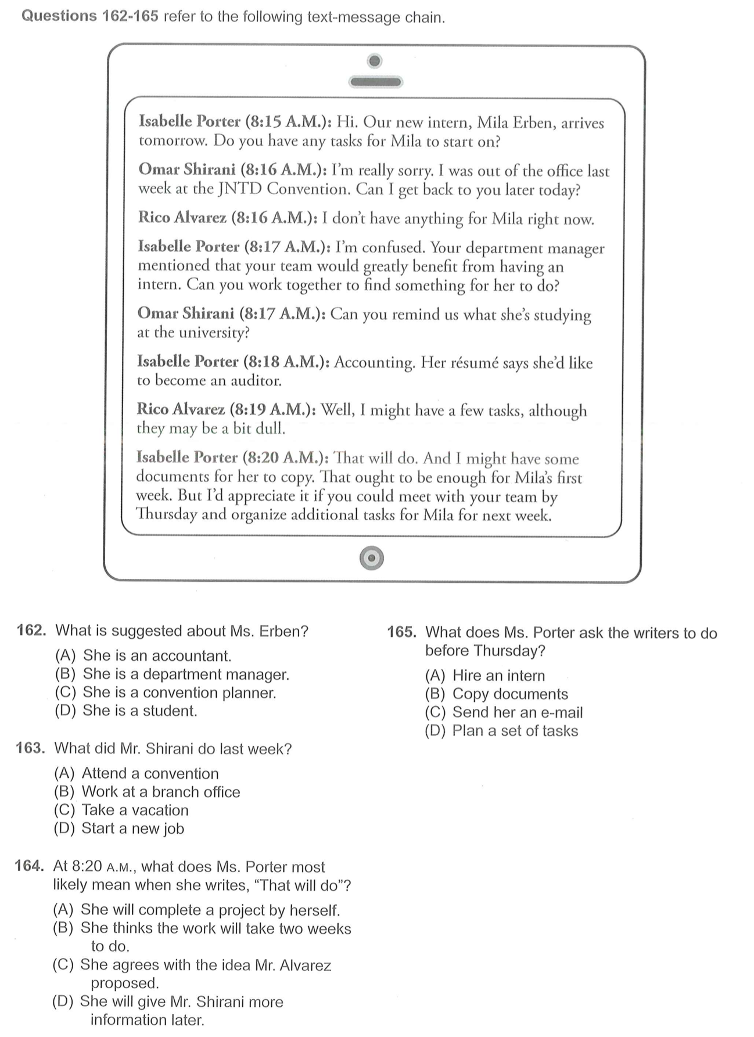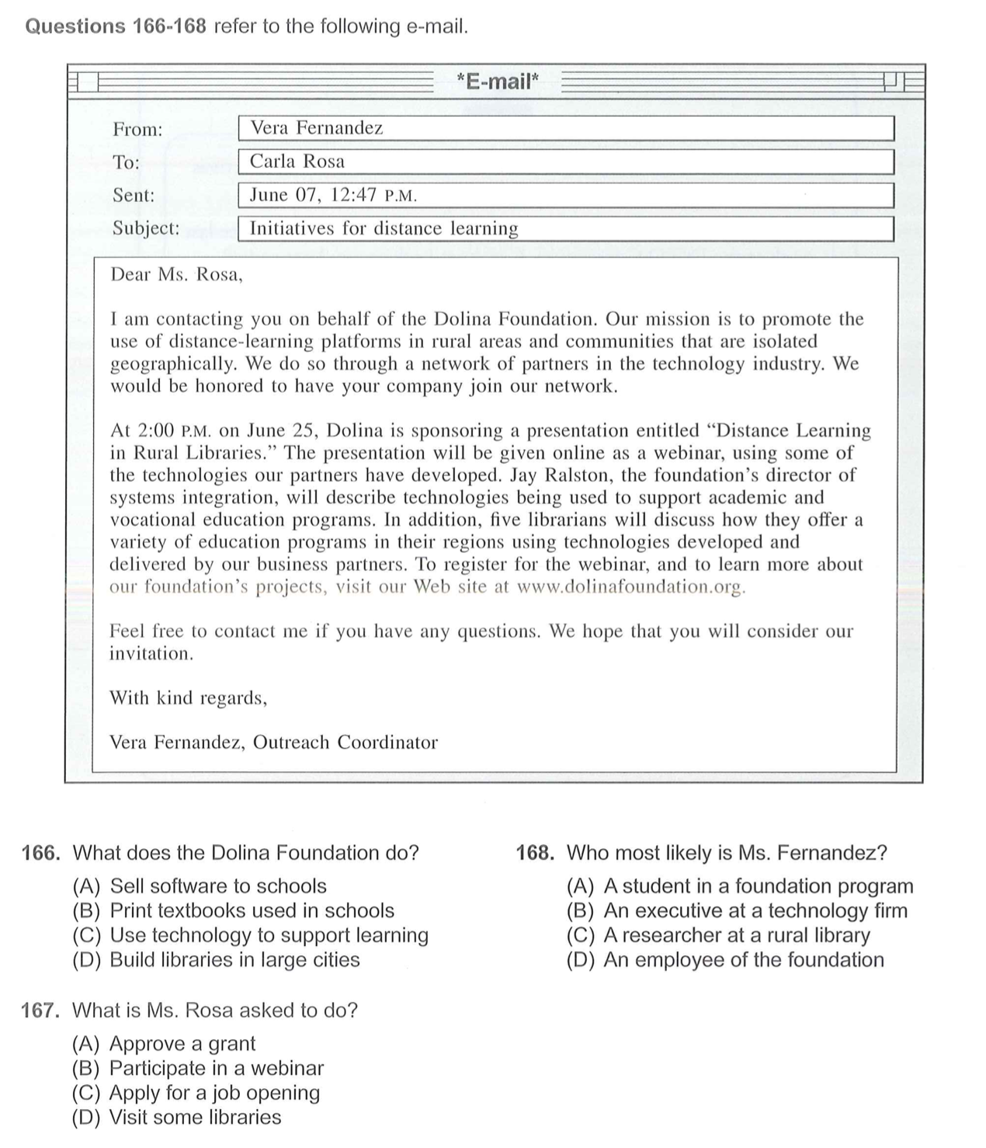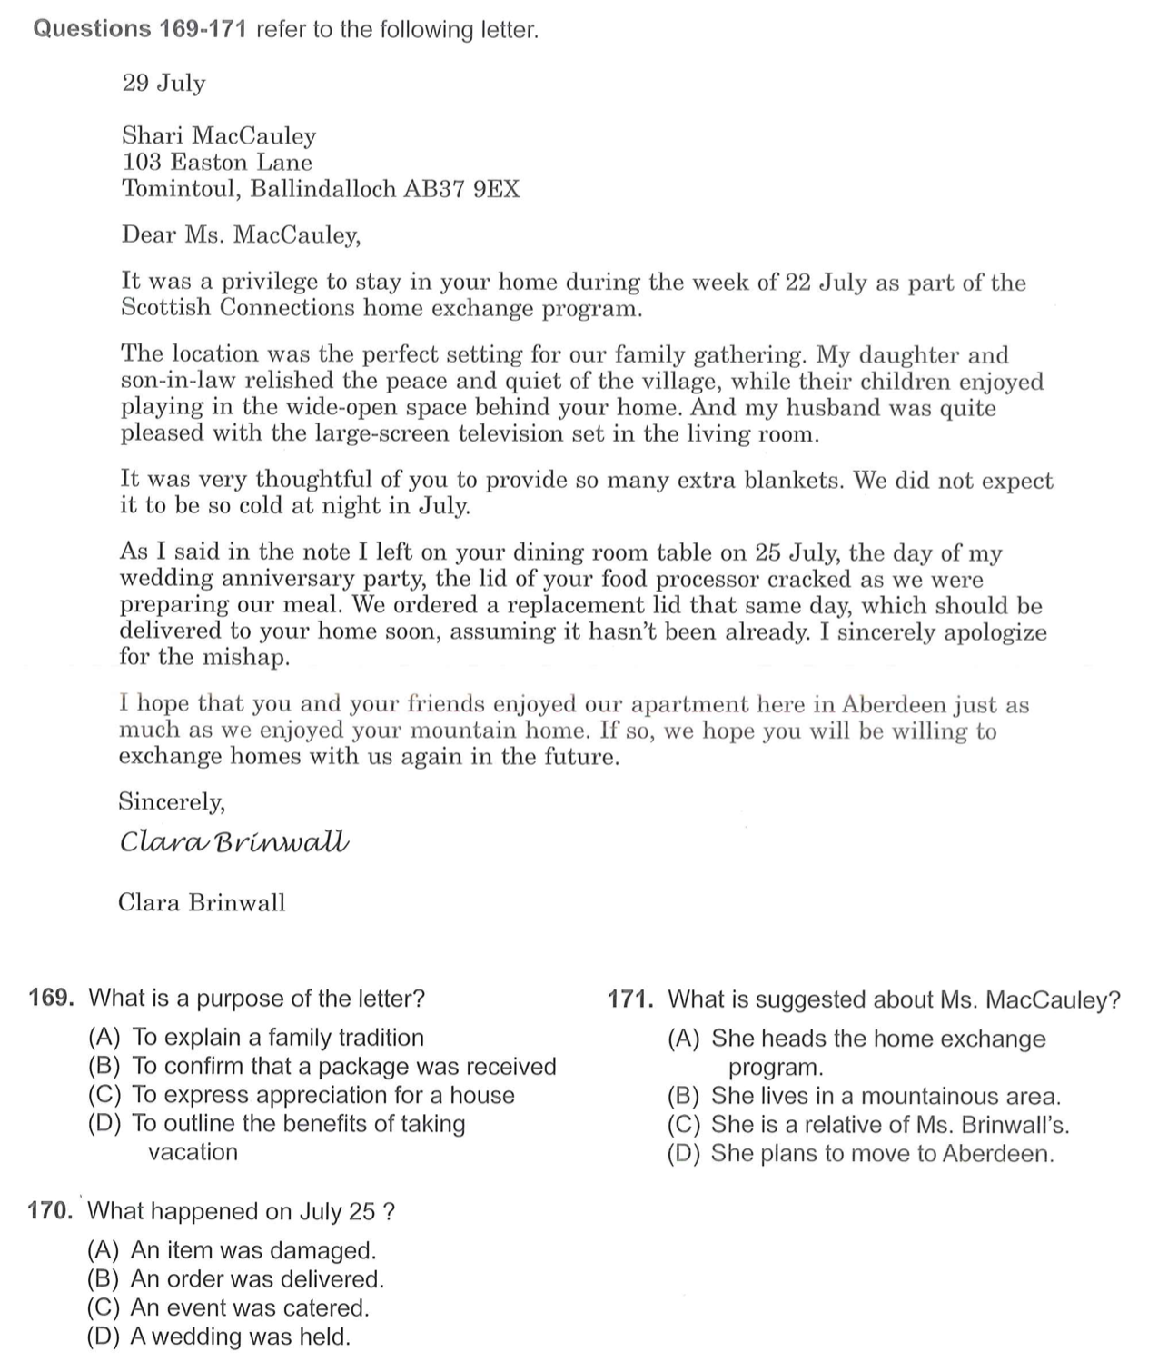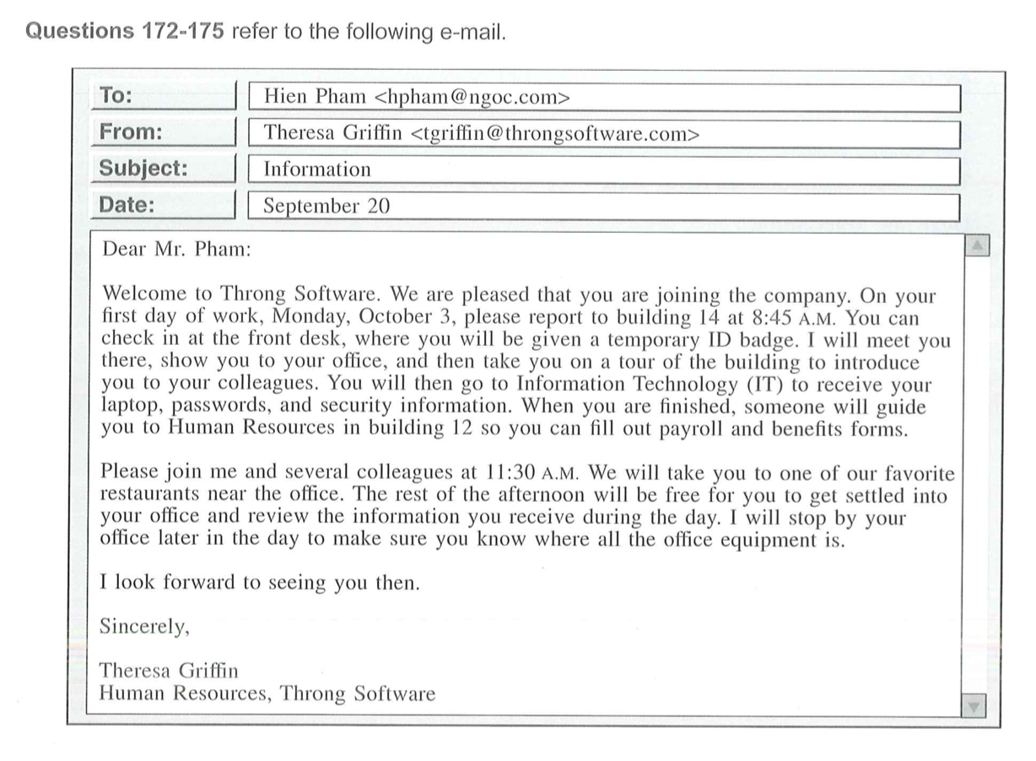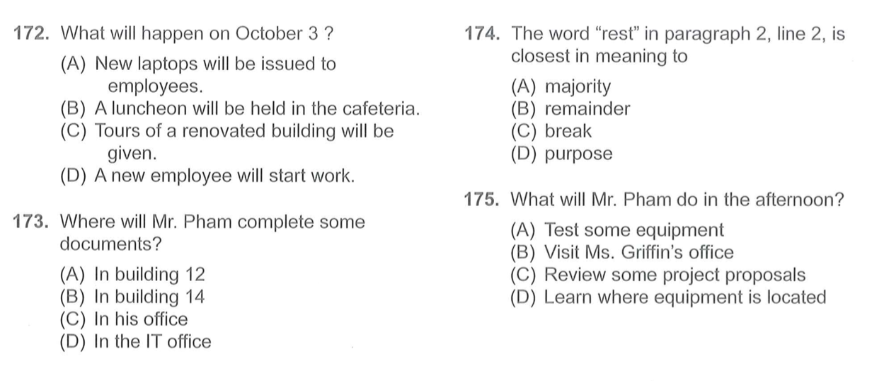

Exercise 2: Double - Triple Passage 176-195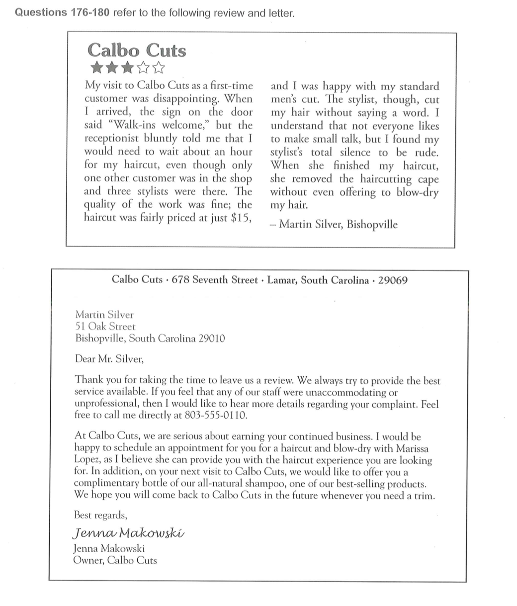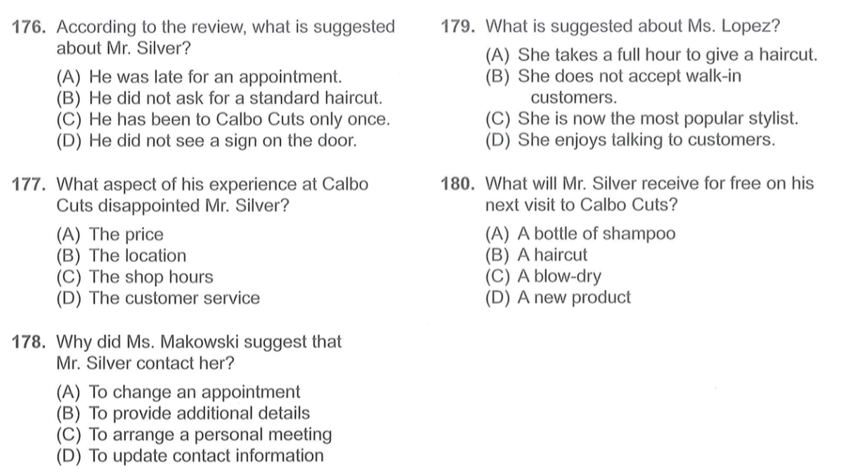

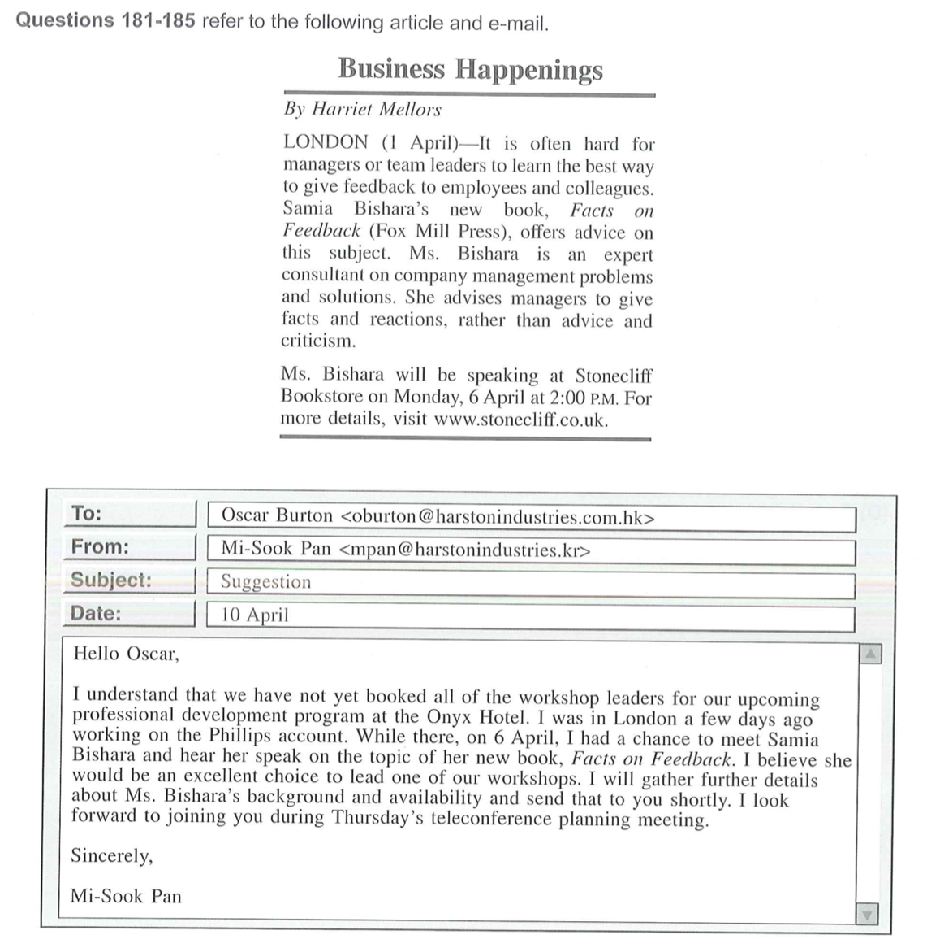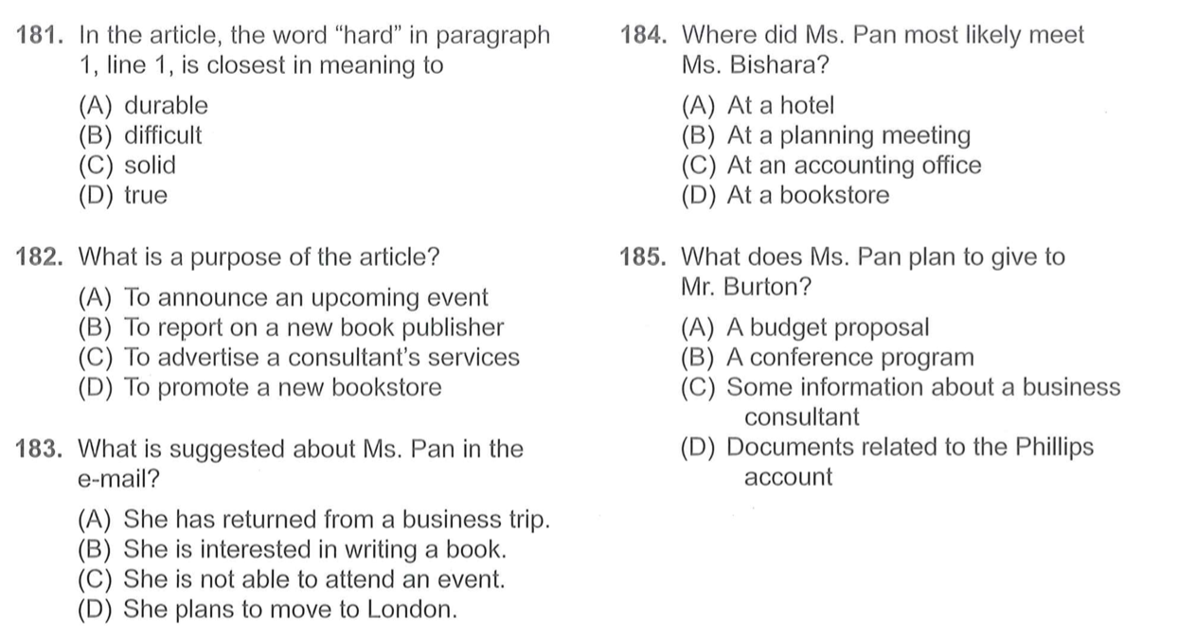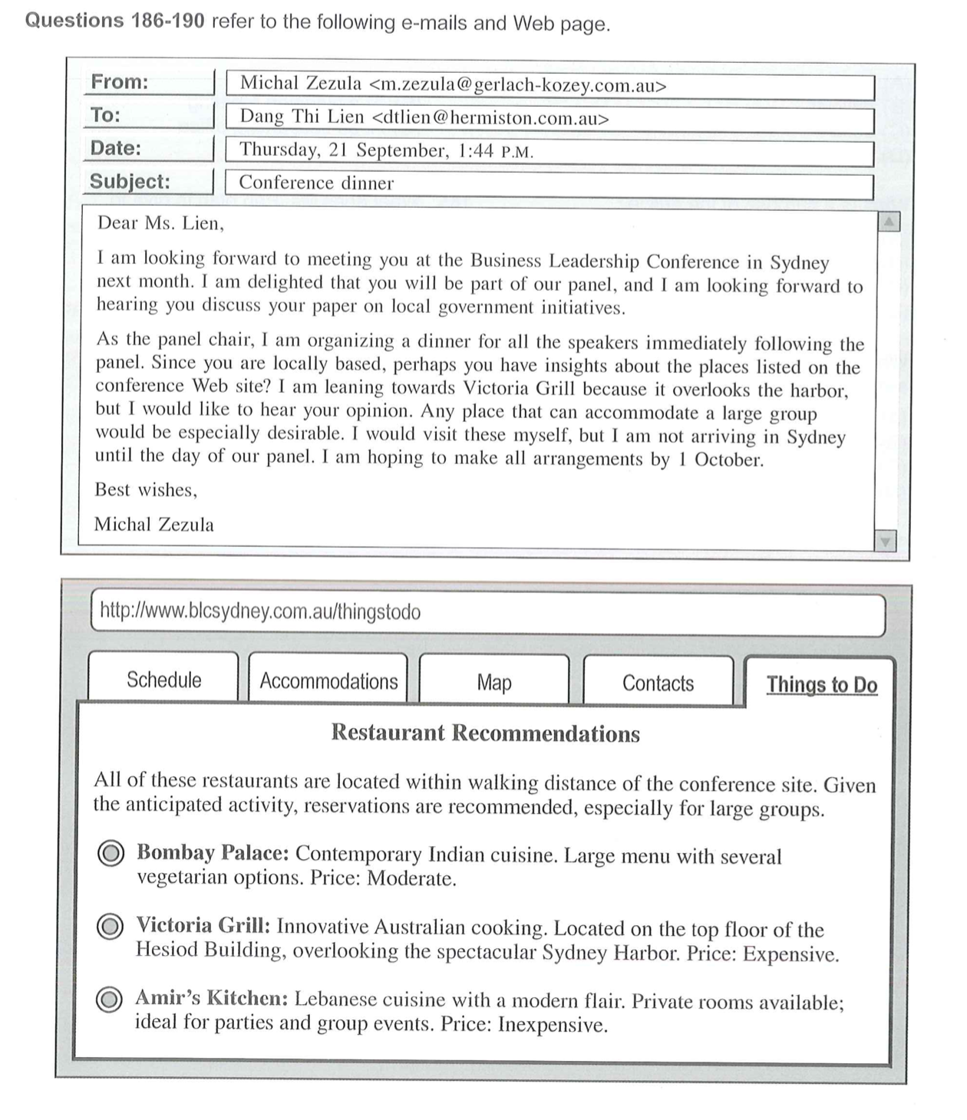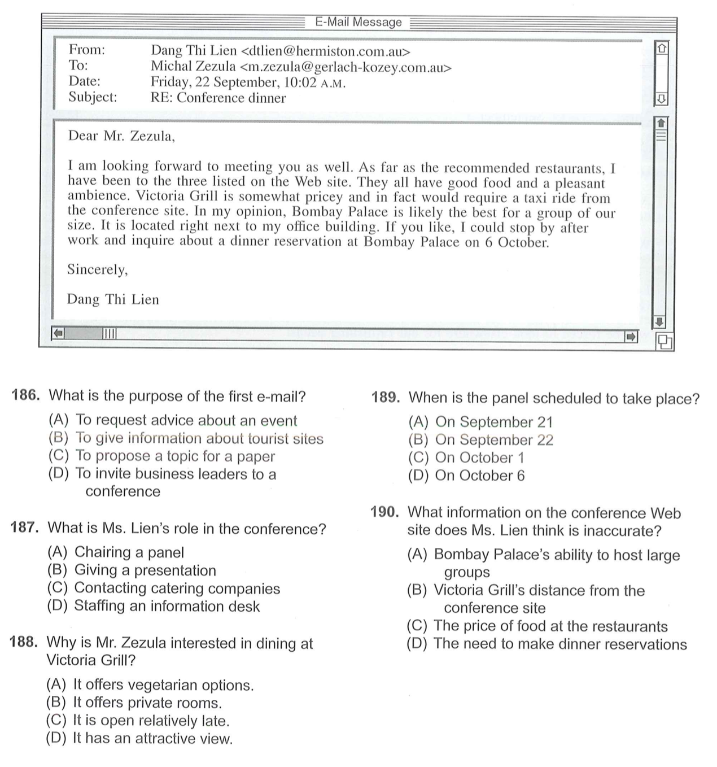

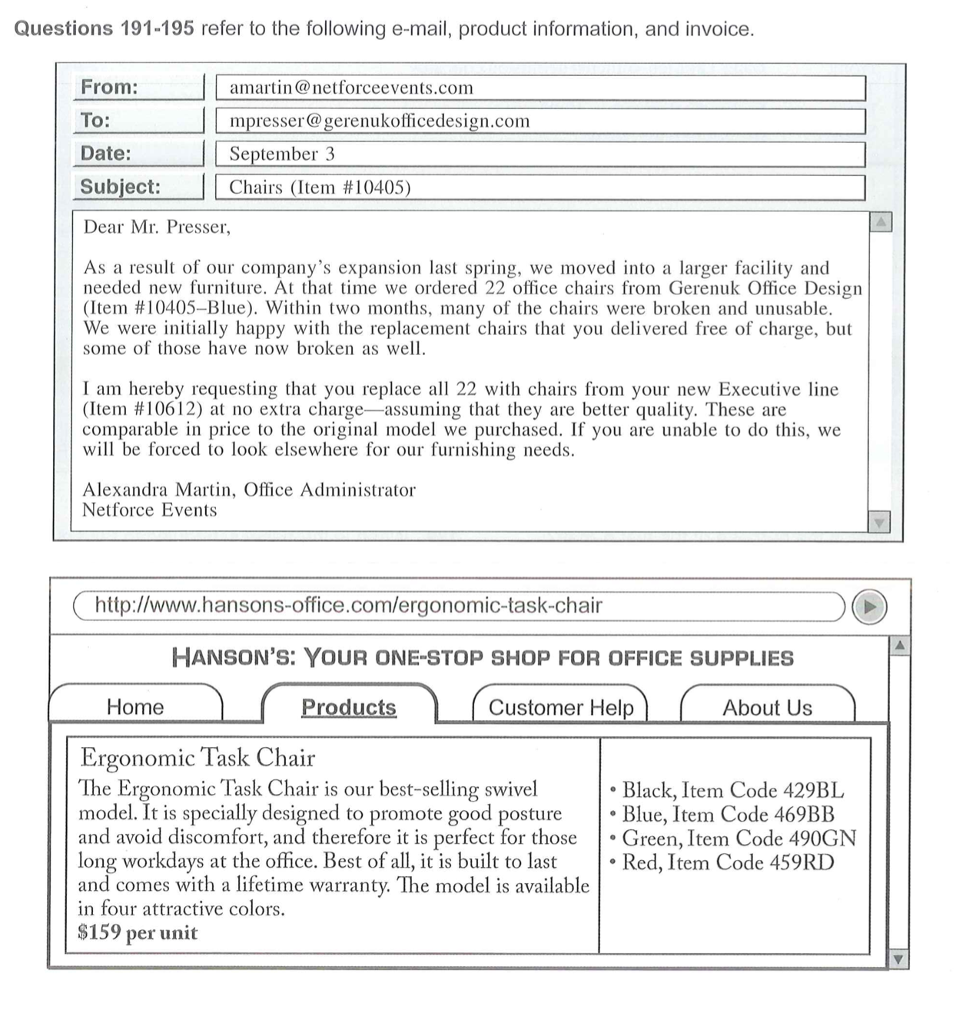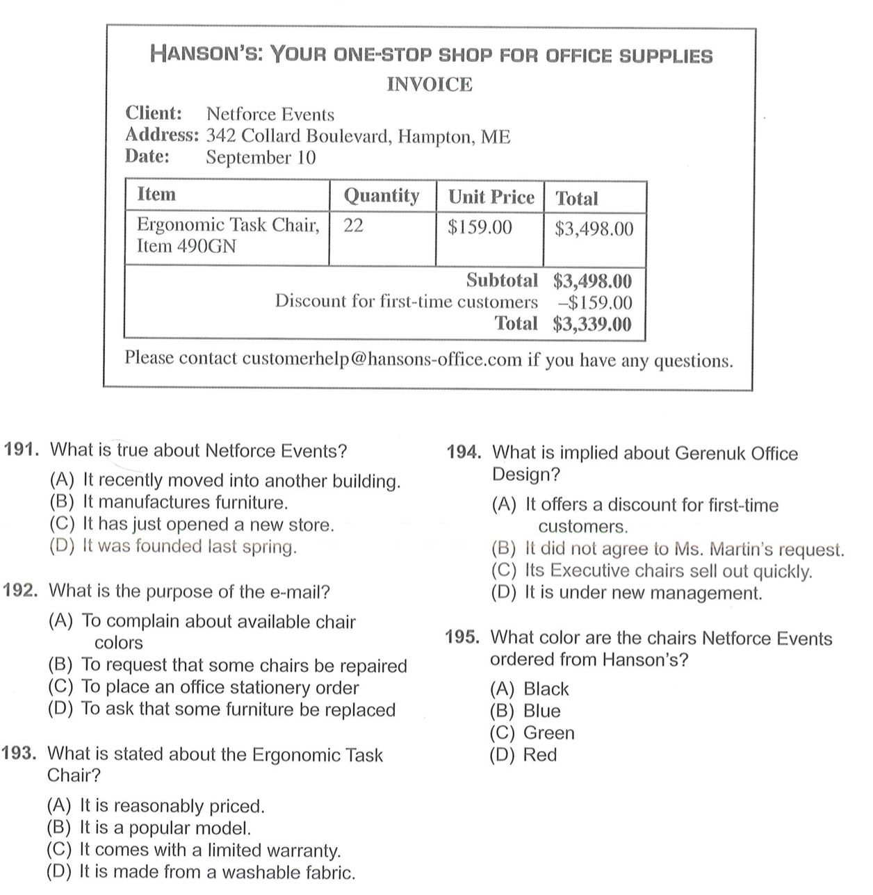

**HOMEWORK**

Exercise 1: Listen and choose the correct answer (25 questions)

(File 18.2)

|  |  |  |  |
| --- | --- | --- | --- |
| 7 | A | B | C |
| 8 | A | B | C |
| 9 | A | B | C |
| 10 | A | B | C |
| 11 | A | B | C |
| 12 | A | B | C |
| 13 | A | B | C |
| 14 | A | B | C |
| 15 | A | B | C |
| 16 | A | B | C |
| 17 | A | B | C |
| 18 | A | B | C |
| 19 | A | B | C |
| 20 | A | B | C |
| 21 | A | B | C |
| 22 | A | B | C |
| 23 | A | B | C |
| 24 | A | B | C |
| 25 | A | B | C |
| 26 | A | B | C |
| 27 | A | B | C |
| 28 | A | B | C |
| 29 | A | B | C |
| 30 | A | B | C |
| 31 | A | B | C |

Exercise 2: Listen to the conversations and choose the correct answer

(39 questions) (File 18.3)

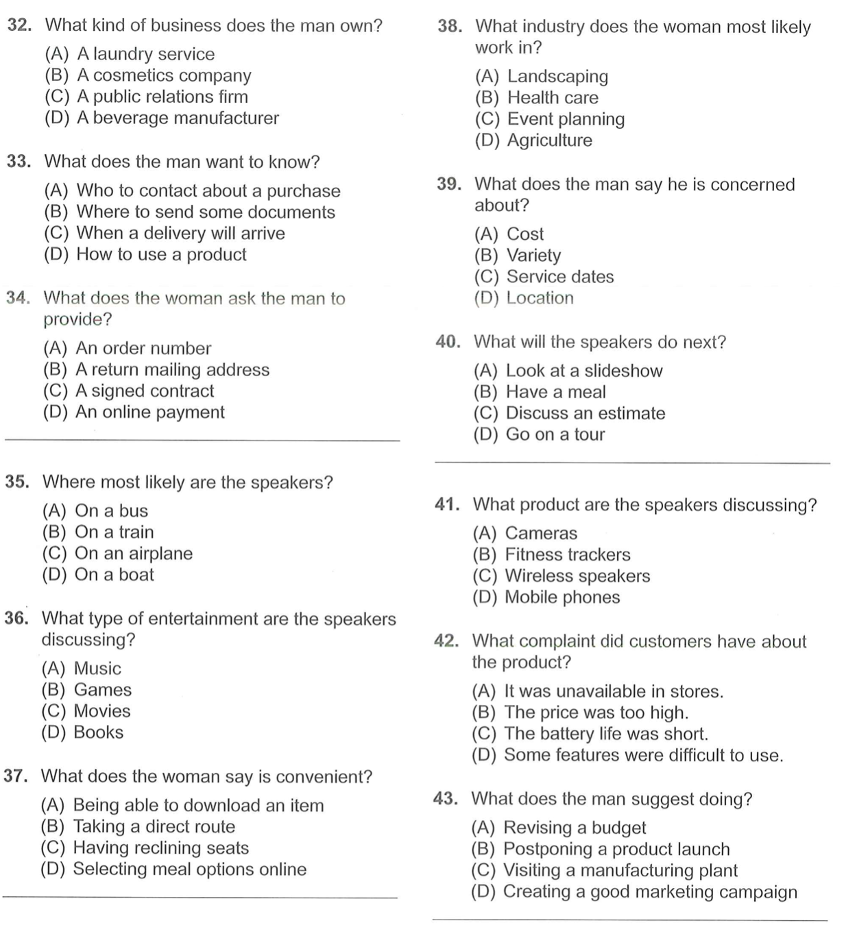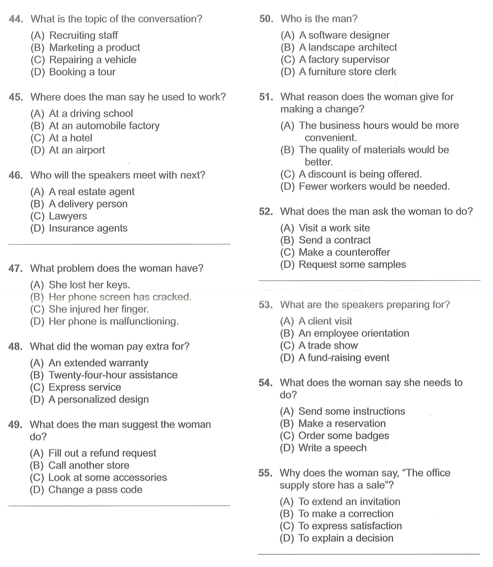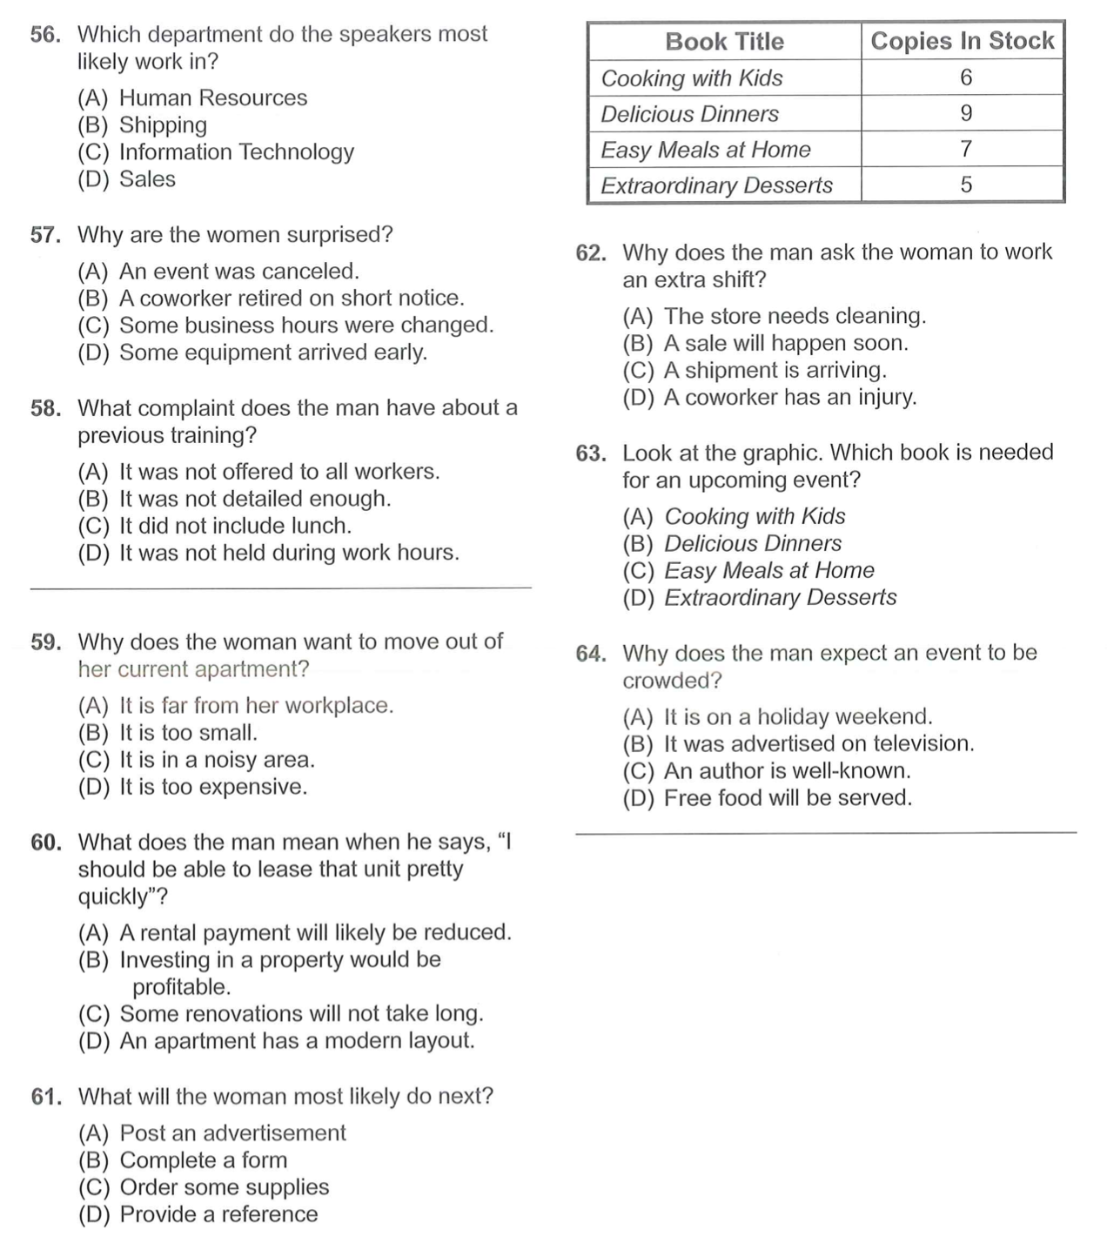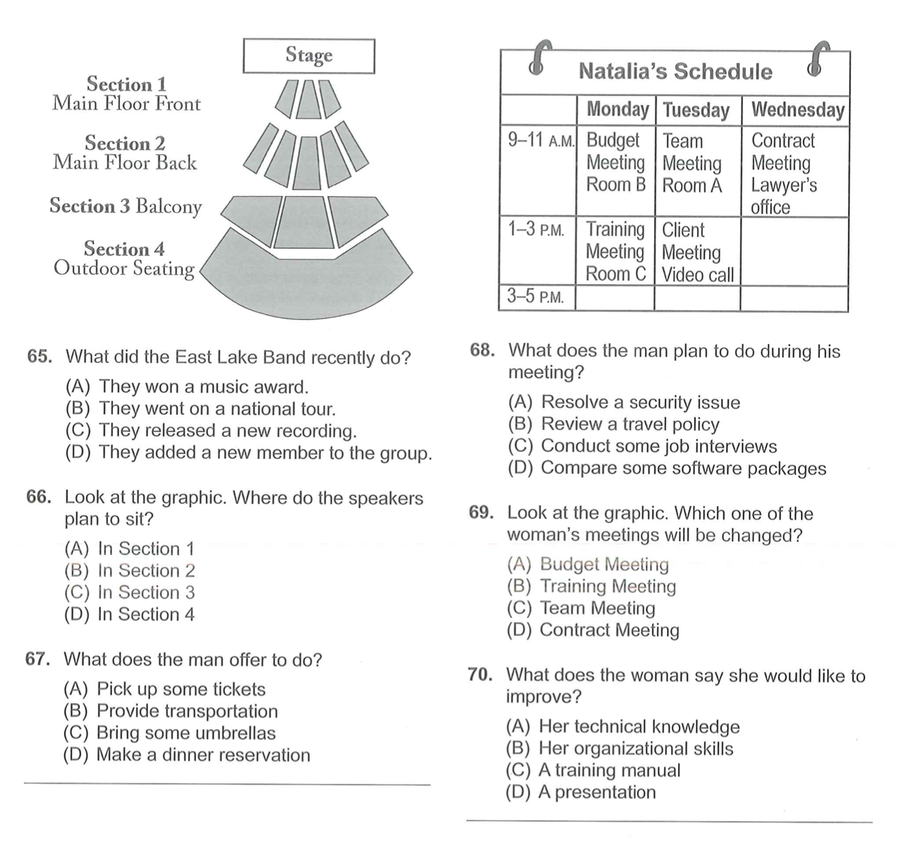

Exercise 3: Listen to the talks and choose the correct answer

(30 questions) (File 18.4)

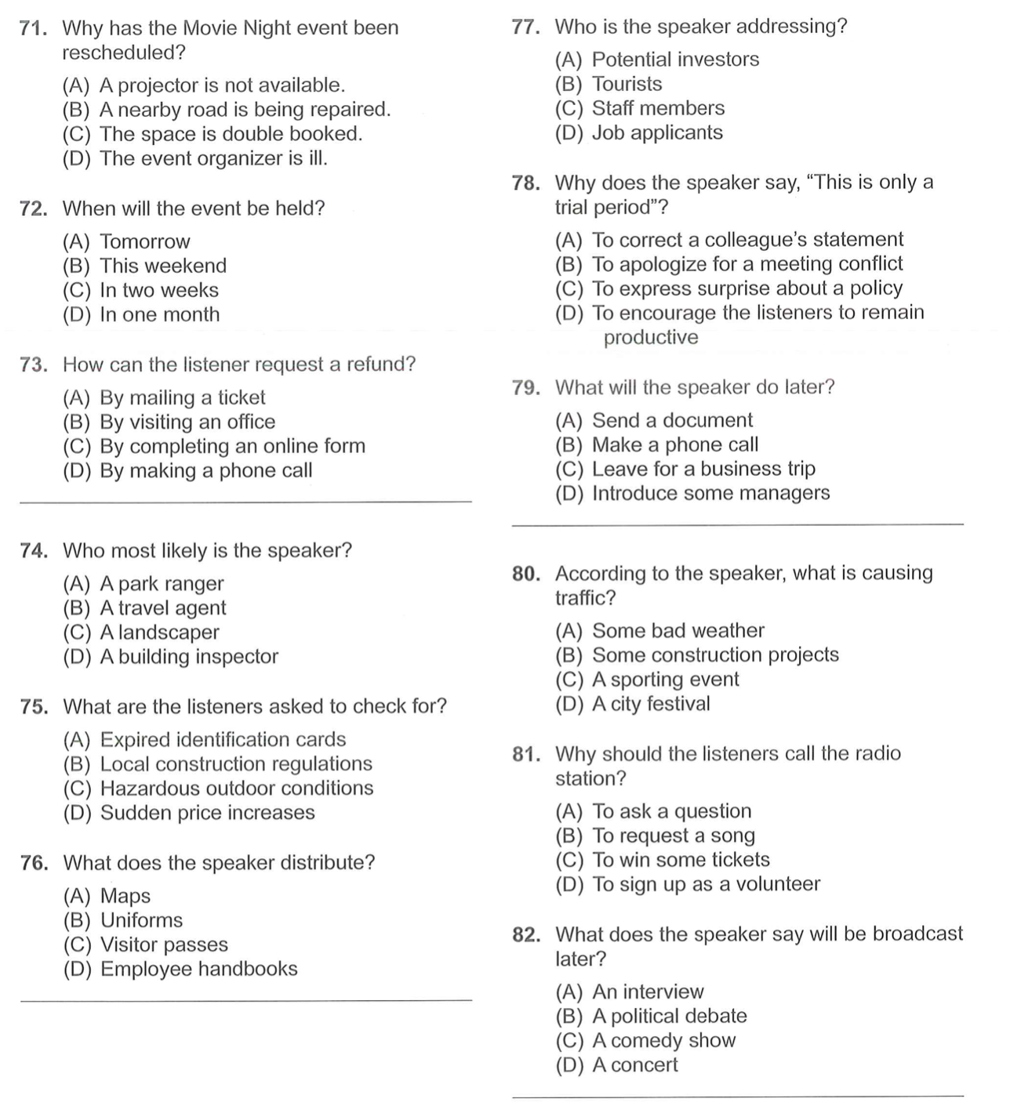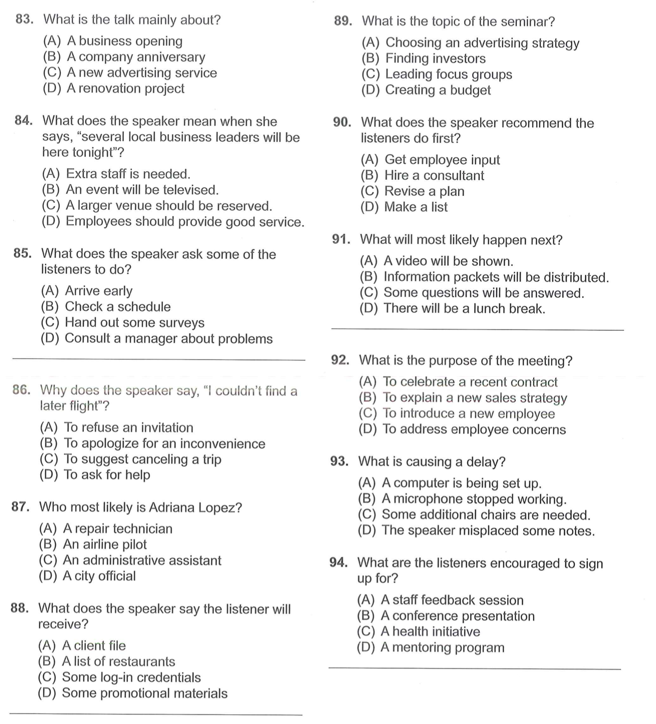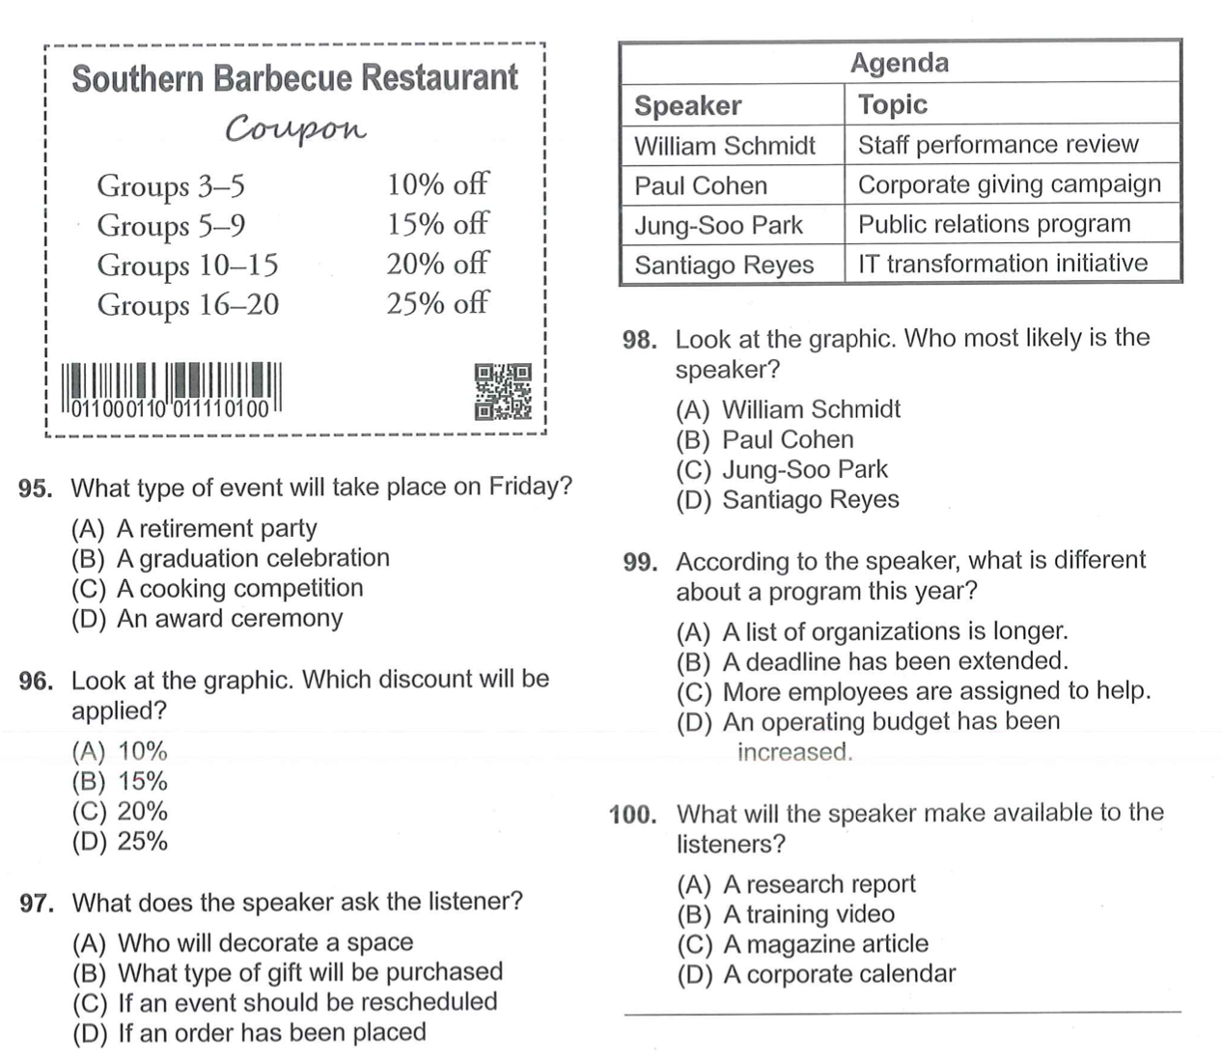

Exercise 3: Read the passages carefully and choose the correct answer

